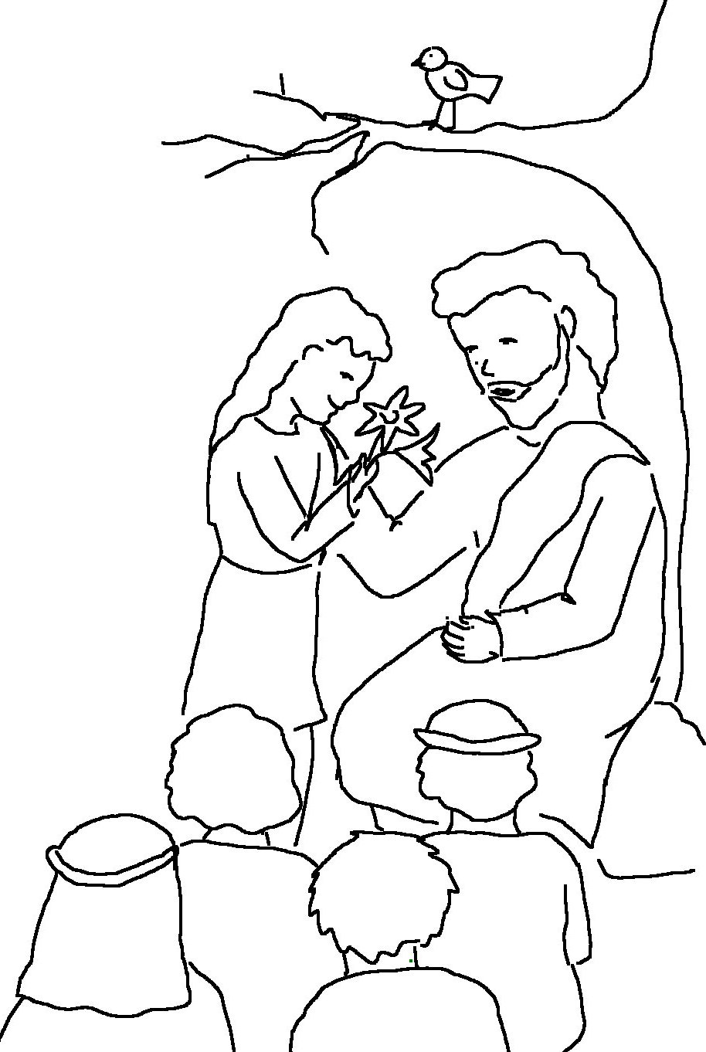

The _ _ _ _ is my shepherd;
I have all that
I _ _ _ _.
Psalms 23:1 _{NLT}

